How to Install and Set Up GitHub for the First Time
This document explains, step by step, how to install Git, set up GitHub for the first time on your machine, configure your username and email, and clone (download) a repository.

1. What You Need
- A computer (Windows, macOS, or Linux)
- Internet connection
- A GitHub account (https://github.com)
- Basic knowledge of using the command line (Terminal or Command Prompt)
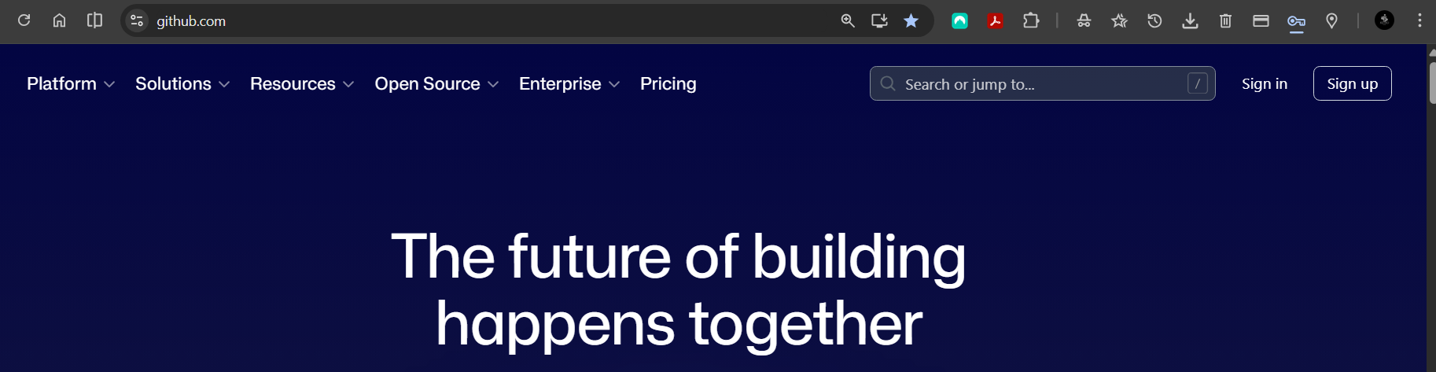

2. Install Git
Git is the tool that allows your computer to communicate with GitHub.
Windows:
1. Go to https://git-scm.com/download/win
2. Download the installer
- This is where you Download the installer
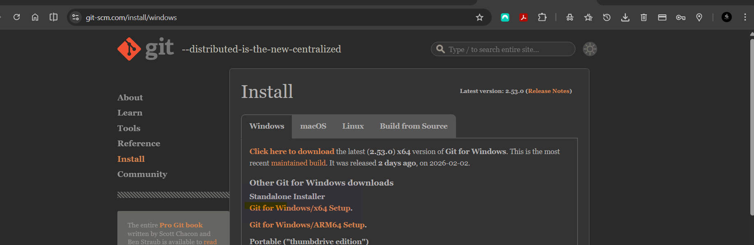

- This is how the downloader looks like

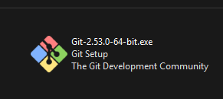
3. Run the installer and keep the default settings
4. Finish installation
- Once Downloaded this is what you will see on your Machine
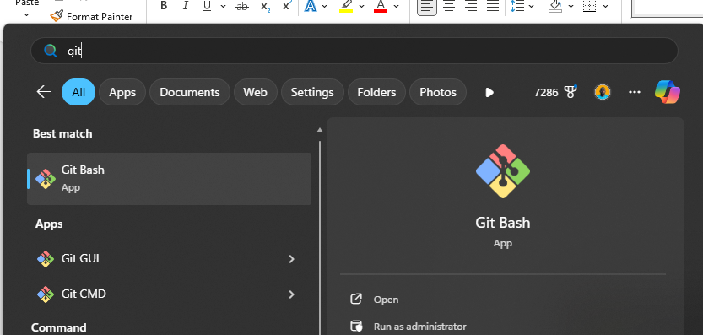

macOS:
1. Open Terminal
2. Type: git --version
3. If Git is not installed, macOS will prompt you to install it
4. Follow the on-screen instructions
Linux:
1. Open Terminal
2. Run:
sudo apt update
sudo apt install git

3. Verify Git Installation
Open Terminal or Command Prompt and run:
git --version
If Git is installed correctly, you will see the installed Git version.

4. Configure Git (First-Time Setup)
You must configure your username and email. These details are used to track your changes.
Set your username:
git config --global user.name "Your Name"
Set your email address:
git config --global user. Email "your-email@example.com"
Example:
git config --global user.name "Ketro Sithole"
git config --global user. email “ketro@example.com”
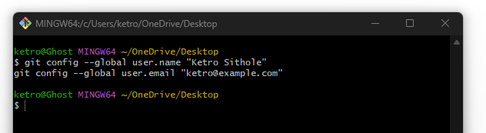

To confirm your configuration, run:
git config --global –list

5. Install GitHub Desktop (Optional)
If you prefer a graphical interface instead of the command line:
1. Go to https://desktop.github.com
2. Download GitHub Desktop
3. Install and sign in with your GitHub account

6. Clone (Download) Your First Repository
Cloning means downloading a project from GitHub to your local machine.
Steps:
1. Go to a repository on GitHub
2. Click the green 'Code' button
3. Copy the HTTPS URL
In Terminal or Command Prompt, run:
git clone https://github.com/username/repository-name.git
Example:
git clone https://github.com/ketro/my-first-project.git

7. Navigate Into the Project Folder
After cloning, move into the project directory:
cd repository-name

8. Basic Git Commands You Should Know
- git status → Check file changes
- git add . → Stage changes
- git commit -m "message" → Save changes
- git push → Upload changes to GitHub
- git pull → Download latest changes

9. Conclusion
You have now successfully installed Git, configured GitHub for the first time, and cloned your first repository. You are ready to start working with GitHub.
